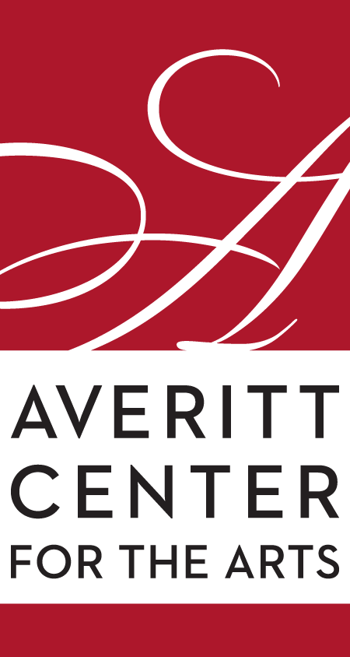
Rahn Hutcheson
Executive Director
Averitt Center for the Arts
P.O. Box 926 • 33 East Main Street
Downtown Statesboro • (912) 212-2787
www.averittcenterforthearts.org
rhutcheson@averittcenterforthearts.org

Comedy, Painting, Singing and Dancing in September

Belly-laughing comedy, inspired artwork, magnificent operatic tones, and colorful folk dancing highlight this month at the Averitt Center for the Arts.
The first Barefoot Comedy show off the season comes to the Jan Brown Anderson stage of the Emma Kelly Theater on September 1.
Brandon Vestal has appeared on NBC’s Last Comic Standing, Man Up Stand Up, Comedy Time TV, FOX’s Laughs, has been a finalist in the World Series of Comedy, named the “Best of the West” at the Detroit Comedy Festival and was a Sirius XM Radio’s Comedian of the Month. The Oklahoma funnyman was the winner of the Hollywood Comedy Festival.
His low-key, deeply personal, and honest style has made him a fast favorite in the comedy world, a “Don’t Miss” for college audiences, and a club favorite. He puts on an amazing show and is a definite must-see. Brandon’s mom will vouch for all of this.
The Barefoot Comedy series was created and is hosted by Savannah native Collin Moulton.
On September 8, the artwork of Elsie Hill Howington, a native of Savannah and an associate professor in the Betty Foy Sanders Department of Art at Georgia Southern University, will be on display in the Averitt Center’s Main Gallery.
“I find inspiration and endless possibilities for non-representational forms in demolition sites: decontextualized structures, piles of twisted metal and pipe, broken concrete, and shattered glass,” said Howington. “Through monotype, painting, and sculpture, I have rearranged, isolated, and combined this imagery in order to develop new artworks. The images are broken down into monotypes, manipulated in the paintings, and transformed in the sculptures. Each medium that I use defines the parameters for color, texture, and shape that propel the artworks further away from the original source material. As the work progresses, the imagery in the artworks becomes more codependent upon each other and I am inspired by new things like soft-serve ice cream swirls, strange attractors, and engine parts. “
The reception, which begins at 5:30 p.m., is sponsored by Burney Marsh and John Tucker, Bill and Virginia Anne Franklin Waters, Lawrence and Kathleen Smith, Drs. Patrick and Theresa Novotny and the Statesboro Regional Art Association. The artist talk begins at at 6 p.m.
On September 9, Dr. Tamara Harper will be highlighted in the first ONE series of the season. The ONE series, exclusively sponsored by Brinson, Williams and Groomes Insurance, features a local gifted individual for 90 minutes of personal discussions and performances. Dr. Harper is a magnificently gifted lyric soprano who teaches at Georgia Southern University, is the director of music at the Sylvania First United Methodist Church and is one of the directors of the Statesboro Youth Chorale. She will share his personal life experiences with host Ressie Fuller and then perform.
The ONE series is exclusive sponsored by Brinson, Williams and Groomes Insurors.
The monthly Paint-n-Party will also be held on September 9 with Erika Busbee leading budding artists in painting a whimsical cow wearing a floral headdress.
No experience is necessary to just come and have fun with friends. Boro Takeout provides the snacks, and you can bring your favorite drink! (21 years old and over please) Art supplies and a 16 x 20 canvas and art supplies are included as you create your very own masterpiece.
​ And don’t forget that Averitt Center offers an exciting array of classes for children, teenagers and adults in dance, theater, and visual arts as well as private-lesson instruction in music, dance and visual arts.
Our instructors are practicing artists within their fields of expertise. These fun, informative, and creative programs are designed to build upon student achievement and growth. Come join the fun and learn something new. With over 40 classes to choose from, there's something for everyone at the Averitt.
All meet in the late afternoon or early evening (homeschool classes meet in the late mornings or early afternoons) at one of the four Averitt campuses. Classes are grouped by age and ability level. Class tuition varies and Averitt members do receive discounts.
For more information on events, classes or workshops, visit our website at www.averittcenterforthearts.org or contact the Averitt Center at 912-212-2787.

