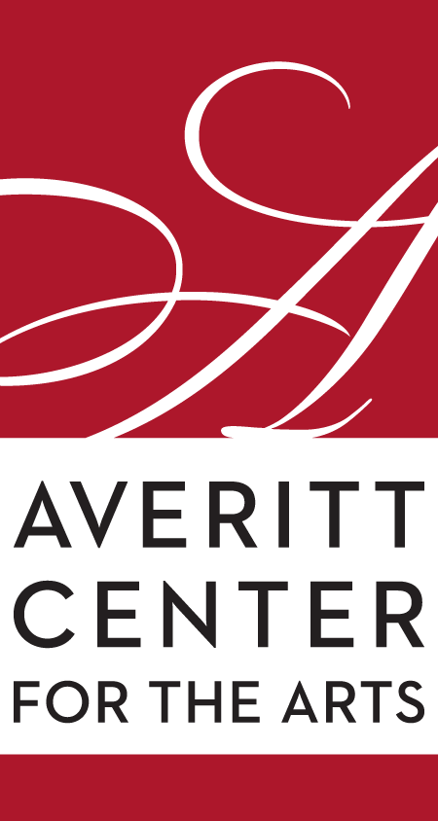
Rahn Hutcheson
Executive Director
Averitt Center for the Arts
P.O. Box 926 • 33 East Main Street
Downtown Statesboro • (912) 212-2787
www.averittcenterforthearts.org
rhutcheson@averittcenterforthearts.org

Art education classes start in August
Visual arts, dance, theater and music make up the four basic areas of the many Art Education classes that begin this month at the four campuses of the Averitt Center for the Arts.
Enrolling in an Averitt Center art class is one of the best investments parents can make in helping their children develop. Register them to learn something new, sharpen old skills, make friends, and have fun.
Why is arts education important to you and your family?
Students who participate in arts-learning experiences often improve their achievement in other realms of learning and life. A growing number of studies presents compelling evidence connecting student learning in the arts to a wide spectrum of academic and social benefits. Additionally, research has shown that what students learn in the arts may help them to master other subjects such as reading, math, or social studies. And, if that is not enough, arts-involved students watch fewer hours of TV, participate in more community service, and report less boredom in school.
The Averitt’s newest art education program, Little Artists, enters its second year and begins Monday, August 1. This program, housed on the third-floor classroom of Averitt Center Main Building, is a half-day environment from 9 a.m. to noon for pre-school aged children aged 3 to 5. It focuses on learning through play, creating using the arts, helping to develop social skills and sharpening those important foundational abilities needed for school readiness. Tuition is $250 per month ($225 for Averitt members) and has a $15 per month supply fee.
The Art Adventures at the Averitt class also begins Monday, August 1 at 2:30 p.m. The program is housed in the Roxie Remley Center for Fine Arts and is geared for students who are aged five to 11.
It’s focused on art exploration, where students have the opportunity to participate in visual arts, music, theater and dance in four mini-sessions. Art Adventures at the Averitt follows the Bulloch County School System calendar and will not meet during school holidays. Transportation to this program may be available for children who attend one of the schools in the city of Statesboro.
Art Adventures at the Averitt takes place Monday-Friday from 2:30-6:00 p.m. starting August 1st. Tuition is $220 per month ($200 for Averitt members) with a supply fee of $20 per month.
To learn more about either program or to register, call Tony Phillips at 912-259-9228. Spaces are limited, so act now!
The Averitt Center also offers a wide range of over 50 classes and workshops for children, teenagers and adults in dance, theater, visual arts and music. The visual arts are eight weeks at a time, the theater courses are 10 weeks while others are year-long courses. All meet in the late afternoon or early evening (homeschool classes meeting in the late mornings or early afternoons) at one of the four Averitt campuses and meet once per week. Classes are grouped by age and ability level. Class tuition varies but, as with Little Artists and Art Adventures at the Averitt, members do receive discounts.
The Averitt Center for the Arts is also proud to announce the availability of financial assistance for all educational programs through the Arts for All Scholarship Fund. The fund has been created to assist the financial needs of families interested in attending classes, camps, and workshops at the Arts Center.
If you wish to enroll your child through the Scholarship Fund program, please contact Mr. Phillips at 912-259-9228 or send him an email at tphillips@averittcenterforthearts.org.
Arts training pays dividends over the entire course of a person’s life, no matter where their path may lead.

With classes for people from 3 to 103, the Averitt Center for the Arts has you covered! Register your child in our after-school arts education program Arts Adventures or any of visual arts, theater, dance or music classes. Audition for the Community Theater, join the Statesboro Community Orchestra, take a pottery or drawing class or take private lessons with one of the Arts Center’s outstanding instructors.
Let your creativity and passion run free; register for your class today.
Enrollment for classes is always open. Simply visit the Box Office at the Averitt Center Main Gallery (open 9 a.m.-4 p.m. Monday through Friday), look online at www.averittcenterforthearts.org/camps-classes for full descriptions and enrollment details and call 912-259-9228 or 912-212-2787.

