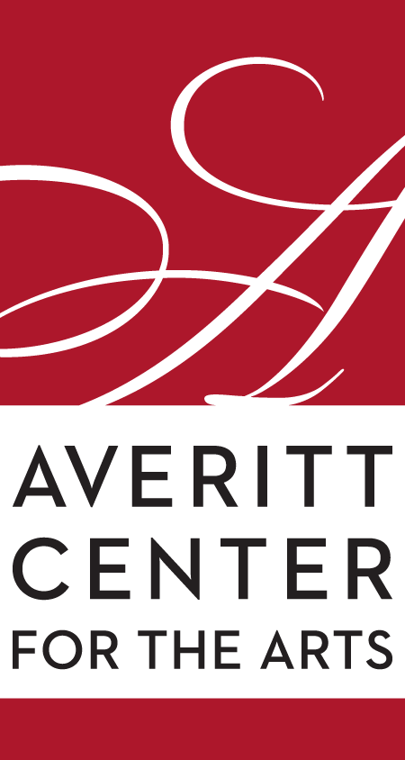
Rahn Hutcheson
Executive Director
Averitt Center for the Arts
P.O. Box 926 • 33 East Main Street
Downtown Statesboro • (912) 212-2787
www.averittcenterforthearts.org
rhutcheson@averittcenterforthearts.org

All gave some, some gave all

On the 11th hour of the 11th day of the 11th month, the American Legion Dexter Allen Post 90, along with the Averitt Center for the Arts and Joiner-Anderson Funeral Home, will pay tribute to the men and women, living or deceased, who served in any branch of the United States Armed Forces in the Emma Kelly Theater.
The annual Veterans’ Day Celebration was cancelled last year due to COVID-19 but was videotaped by Robert Faller of the Averitt Center and produced by the Statesboro Herald. This year’s ceremony will be conducted as normal.
At presstime, plans had not been finalized for this free community event.
Later that afternoon, Bridget Conn, an assistant professor of art at the Armstrong campus of Georgia Southern University, brings her photography and experimental darkroom processes exhibition to the Averitt Center Main Gallery.
No experience is necessary for the monthly Paint-n-Party on Nov. 12 at the Roxie Remley Center for Fine Arts on Vine Street behind Statesboro City Hall.
The $35 price includes a 16 x 20 canvas and art supplies that you will use to create your very own masterpiece. Erika Busbee will guide you through the steps to paint your version of the painting-of-the-month. Just come and have fun with friends and your favorite drink! (21+ to drink). BoroTakeout.com is the sponsor of the event and provides free food.
The dancers of Cotton Rose Dance Studio at the Averitt Center and the Statesboro Youth Ballet will bring the holiday classic, the Nutcracker Ballet, to the EKT stage on Nov. 18-21.
Sponsored by Morris Bank and Jim & Betsy Nichols, the Nutcracker Ballet tells the story of Clara as she and the Nutcracker, which was given to her by Godfather Drosselmeyer, battle the Mouse King. Upon defeating the mice army, the Nutcracker turns into a handsome little prince and both he and Clara are entertained by the Sugarplum Fairy as they travel through the Land of Sweets.
Rebekah Harville Carlisle, the Averitt’s director of dance, has choreographed a fantastic show using the local talent below.
Mr. & Mrs. Stahlbaum: Emily and Brian Dowis
Party Parents: Kristin Leonard, Danielle Adams, Brooks Adams, Nichole Deal, John Parcels, Jan Meinhardt, Ben Hammett, Anastasia Brown, John Wiggins
Maids: Rebekah Carlisle, Darien Adams, Laural Boyles, Rebecca Nessmith
Godfather Drosselmeyer: Jason Evans
Clara: Tessa Salter - Understudy: Anna Kate Croft
Little Nutcracker Prince: Kyler Williams
Fritz: Kyler Williams
Odette and Odile Swan Dolls: Anne, Emma Lummus
Party Girl: Annabelle Carlisle, Addison Smith, Giovanna Spivey, Amaya Moore
Party Boy: Liley Ries Simonin, Chloe Weaver, Vasilisa Apanaskevich, Ava Cliett
Butler: Luke Wiggins
Baker: Brandon Adams
Rat King/Queen: Annie O’Neill - Understudy: Ana Grace Evans
Mice: Maybrie Leonard, Stella Salter, Rose Deal, Marley Tootle, Amastin Beggs, Anastasia Wilson, Ashley Beasley, Everley Skrine, Malcom Couillou
Rats: Emily Noel, Mason Meinhardt, Nadilie Olson, Maria Yanochik, Raegan Green, Rose Thompson, Cindy Rodriguez
The Nutcracker: Rebekah Carlisle
Soldiers: Annabelle Carlisle, Addison Smith, Liley Ries Simonin, Chloe Weaver, Amaya Moore, Giovanna Spivey, Ava Cliett, Vasilisa Apanaskevich, Gayle Hammett
Angels: Maybrie Leonard, Stella Salter, Rose Deal, Marley Tootle, Amastin Beggs, Anastasia Wilson, Ashley Beasley, Everley Skrine, Malcom Couillou
Soldier: Hadassa Spivey
Spanish Solo: Sarah Rawlins - Understudy: Abbie Gunder
Bulls: Annabelle Carlisle, Addison Smith
Arabian: Abbie Gunder (Peacock), Anna Kate Croft, Ana Grace Evans - Understudies: Sarah Rawlins, Annie O’Neil, Katherine Warner
Chinese: Emily Noel, Mason Meinhardt, Nadilie Olson, Maria Yanochik, Raegan Green, Rose Thompson, Cindy Rodriguez
Russian: Sarah Rawlins, Anna Grace Evans, Annie O’Neill - Understudies: Anna Kate Croft, Katherine Warner, Abbie Gunder
Marzipan: Anna Kate Croft, Katherine Warner, Abbie Gunder - Understudies: Sarah Rawlins, Anna Grace Evans, Annie O’Neill
Bon Bons: Annabelle Carlisle, Addison Smith, Amaya Moore, Ava Cliett, Vasilisa Apanaskevich, Chloe Weaver, Iley Reis Simonin, Giovanna Spivey
Mother Ginger; Kenneth Hoopaugh
Dew Drop Fairy: Annie O’Neill - Understudy: Anna Grace Evans
Flowers Corps: Anna Kate Croft, Sarah Rawlins, Abbie Gunder, Laural Boyles, Katherine Warner, Anna Grace Evans
Reserved seat tickets are $25 for adults ($23 for Averitt members, members or veterans of the military, first responders, city and county employees) and $15 for students.
To purchase tickets, simply visit the Box Office at the Averitt Center Main Gallery (open 9 a.m.-4 p.m. Monday through Friday), call 912-212-2787.

